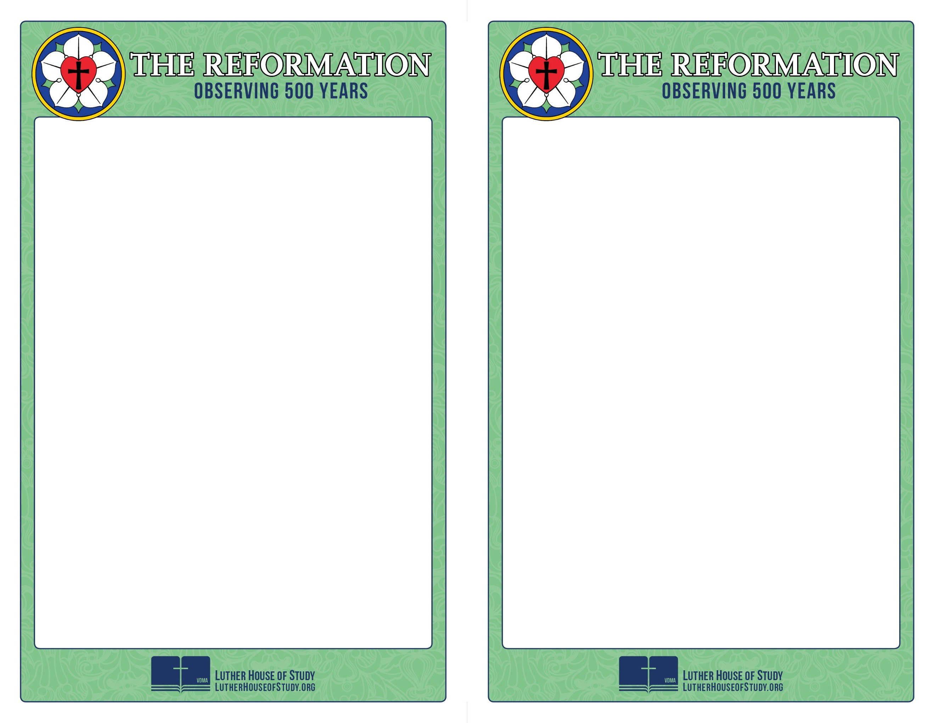
Week 3:
Spreading The Message: Education - Educating Families & Children
From the posting of the 95 Theses to his last breath, it’s clear that care for the people sitting in the pews drove Luther. That care included advocating strongly for educational reform from the earliest years through the university system, and a focus on getting basic Christian education into the homes. The life and salvation of ordinary people drove him in all that he did.

To find out how that care for the simple folk sitting in the pews impacted what Luther did and how he did it, go to www.lutherhouseofstudy.org.

Week 3: Spreading The Message:
Education - Educating Families & Children
From the posting of the 95 Theses to his last breath, it’s clear that care for the people sitting in the pews drove Luther. That care included advocating strongly for educational reform from the earliest years through the university system, and a focus on getting basic Christian education into the homes. The life and salvation of ordinary people drove him in all that he did.

To find out how that care for the simple folk sitting in the pews impacted what Luther did and how he did it, go to www.lutherhouseofstudy.org.

