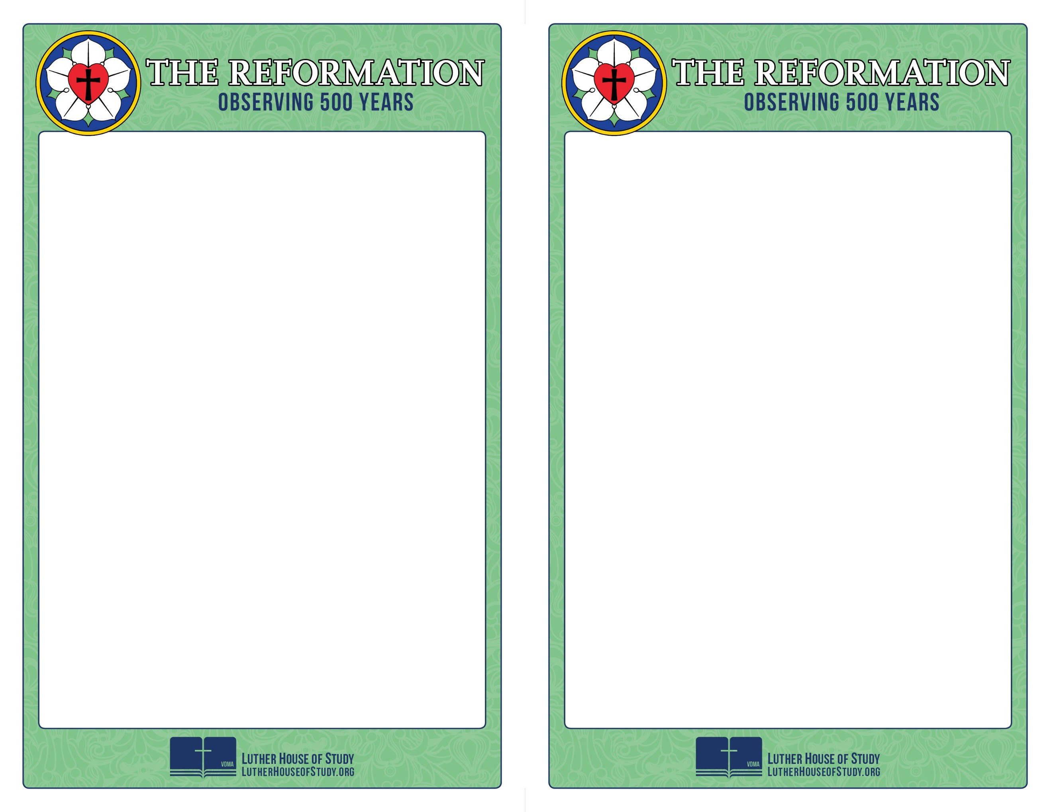
Week 5: Luther And The Jews

During the 500th anniversary of the beginning of the Reformation, many people will point to Luther’s most controversial and problematic writings -- what he wrote about the Jews. Over the years, much ink has been spilled commenting on what Luther wrote.
Some have vilified Luther for his words to such a degree that they advocate for discounting or ignoring everything else he wrote.

Others attempt to diminish the offensiveness and sin of Luther’s words. The content of what Luther wrote, and the consequence of his words, cannot be justified. They are the result of Luther’s own sin.

To see a short video on the subject go to www.lutherhouseofstudy.org.

Week 5: Luther And The Jews

During the 500th anniversary of the beginning of the Reformation, many people will point to Luther’s most controversial and problematic writings -- what he wrote about the Jews. Over the years, much ink has been spilled commenting on what Luther wrote.
Some have vilified Luther for his words to such a degree that they advocate for discounting or ignoring everything else he wrote.

Others attempt to diminish the offensiveness and sin of Luther’s words. The content of what Luther wrote, and the consequence of his words, cannot be justified. They are the result of Luther’s own sin.

To see a short video on the subject go to www.lutherhouseofstudy.org.

