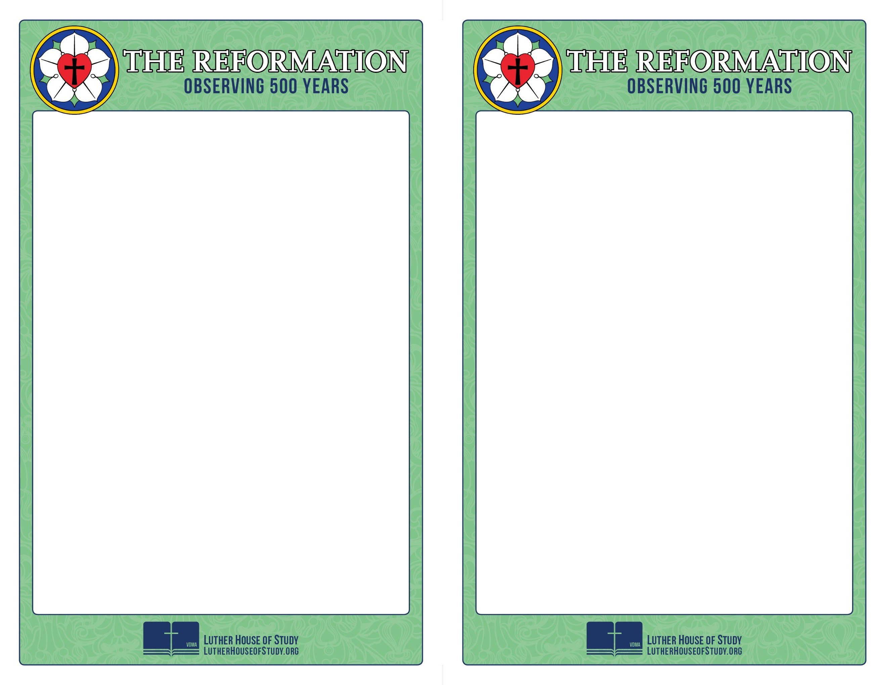
Week 3: Defying The Pope

Luther wasn’t born a reformer or a revolutionary. In fact, toward the end of his life he wrote that in his early years as a monk he would have been willing to murder anyone who would take any obedience from the Pope. But within just a few years, Luther would be unyielding in his opposition to the Pope.

What was it that prompted such a change? And did it last?

To find out more, go to www.lutherhouseofstudy.org.

Week 3: Defying The Pope

Luther wasn’t born a reformer or a revolutionary. In fact, toward the end of his life he wrote that in his early years as a monk he would have been willing to murder anyone who would take any obedience from the Pope. But within just a few years, Luther would be unyielding in his opposition to the Pope.

What was it that prompted such a change? And did it last?

To find out more, go to www.lutherhouseofstudy.org.

