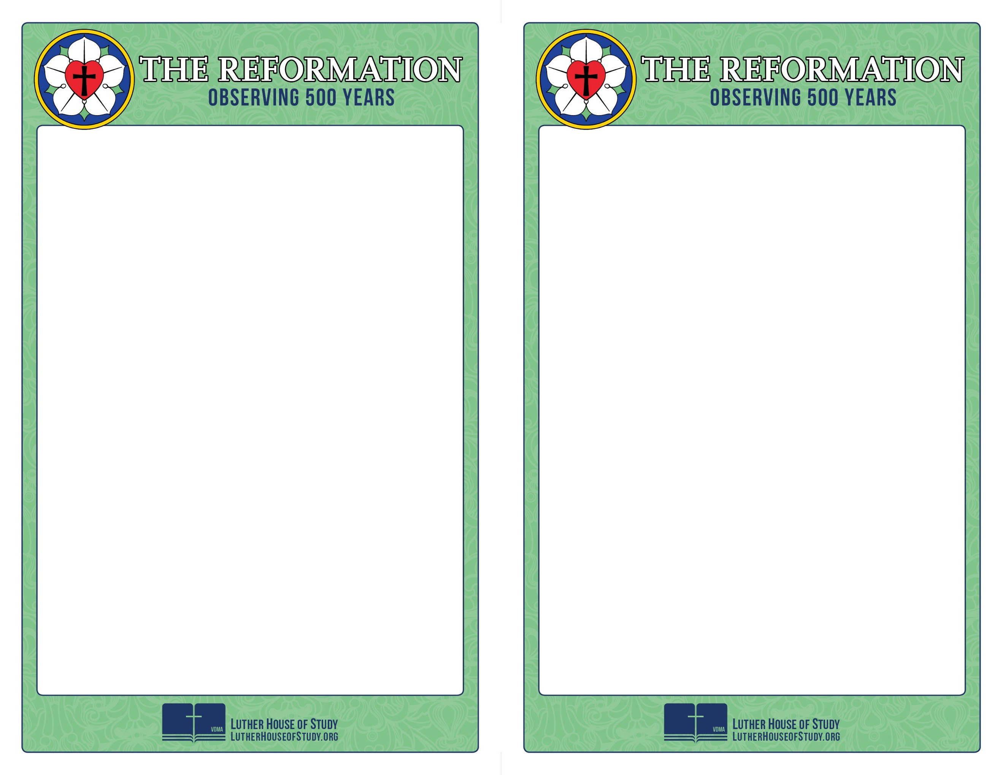
Week 2:
The Role of Secular Leaders

It’s hard for us to imagine, but in Luther’s time politicians played a major role in theological disputes. So much so that it was politicians who brought Luther and another theologian named Zwingli to the table to debate the true significance of the Lord’s Supper.

And it was not uncommon for pastors and theologians involved in theological debates to be exiled from entire territories - simply for their theological positions.

To find out more about the role of secular leaders in the Reformation, go to www.lutherhouseofstudy.org .

Week 2:
The Role of Secular Leaders

It’s hard for us to imagine, but in Luther’s time politicians played a major role in theological disputes. So much so that it was politicians who brought Luther and another theologian named Zwingli to the table to debate the true significance of the Lord’s Supper.

And it was not uncommon for pastors and theologians involved in theological debates to be exiled from entire territories - simply for their theological positions.

To find out more about the role of secular leaders in the Reformation, go to www.lutherhouseofstudy.org .

