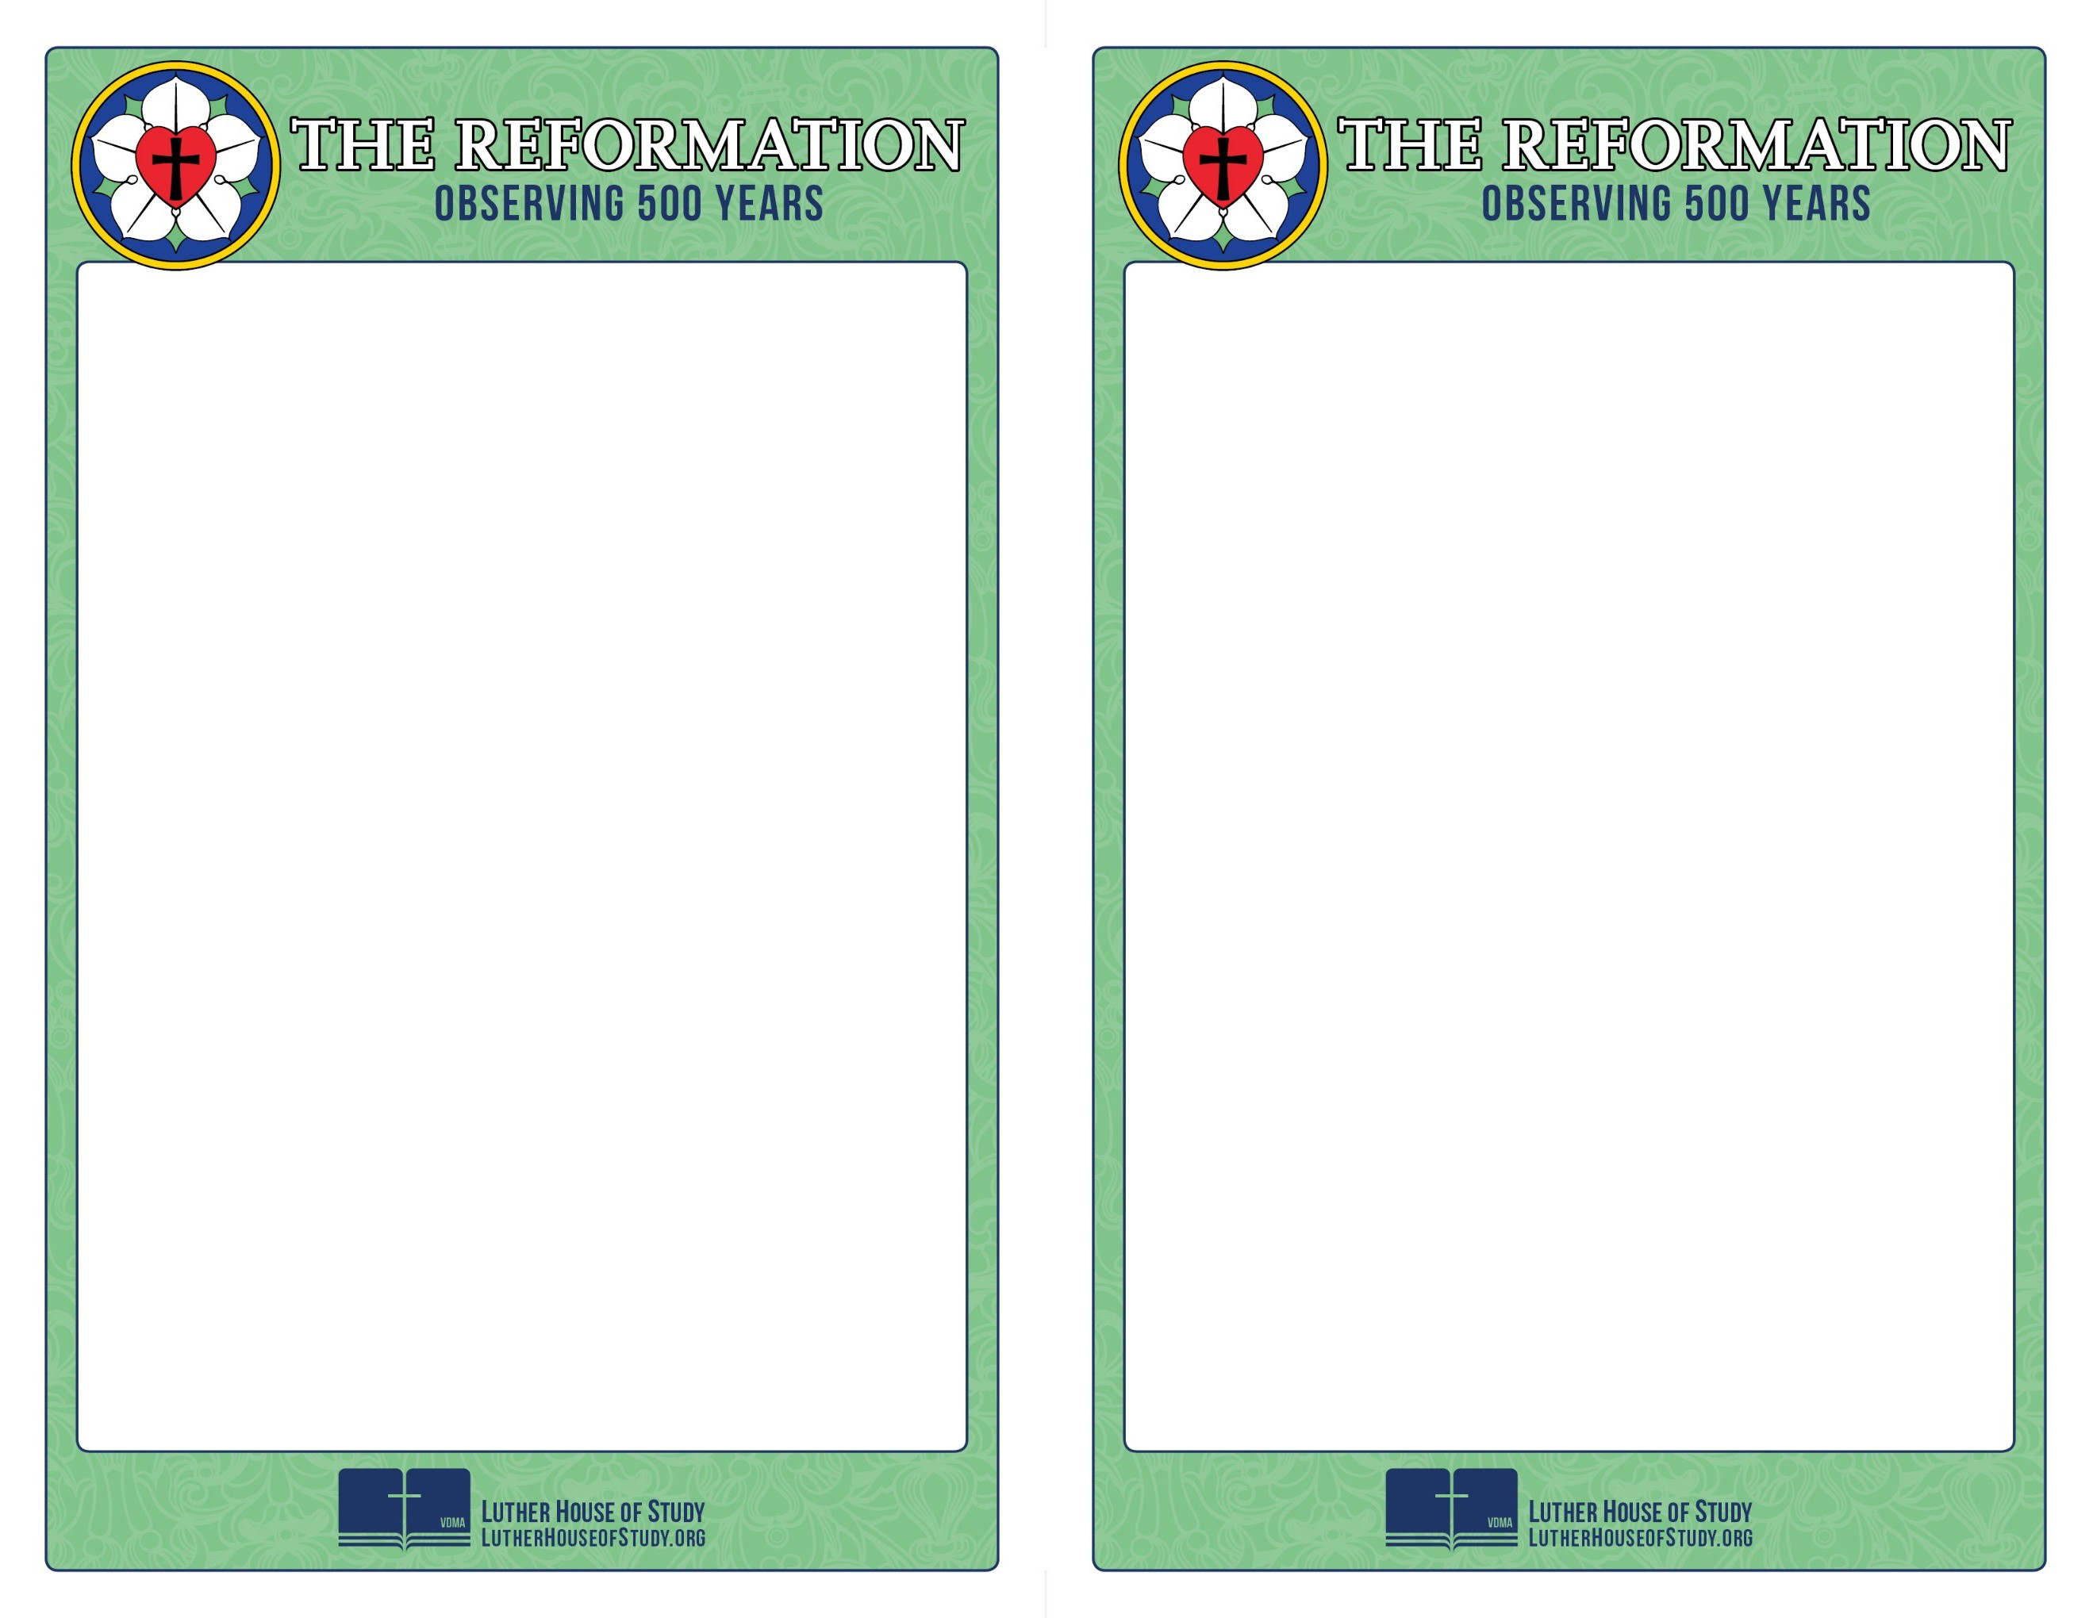
Week 1:
The Politics of Luther's Time

It may surprise you to know that in Luther’s time religion and politics were completely intertwined. So much so that people didn’t need to have any religious training in order to be appointed a bishop. And the Pope’s army was as formidable as any army of the time. Politics and military allegiances played a big role in theological disputes.

So how did Luther work in that environment? And what impact did politics have on the Reformation?

Go to www.lutherhouseofstudy.org to learn more.

Week 1:
The Politics of Luther's Time

It may surprise you to know that in Luther’s time religion and politics were completely intertwined. So much so that people didn’t need to have any religious training in order to be appointed a bishop. And the Pope’s army was as formidable as any army of the time. Politics and military allegiances played a big role in theological disputes.

So how did Luther work in that environment? And what impact did politics have on the Reformation?

Go to www.lutherhouseofstudy.org to learn more.

